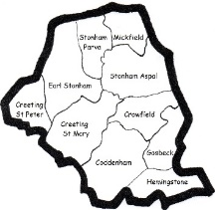
Wordsearch – Trinity 13
Based on the Readings Deuteronomy 4. 1-2, 6-9, James 1. 17-27,
Mark 7. 1-8, 14-15, 21-23

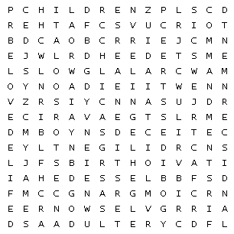

ABOVE | ACT | ADULTERY
ANCESTORS | ANGER | AVARICE
BELOVED | BIRTH | BLESSED
BRIDLE | BRONZE | CHARGING
CHILDREN | COMMANDMENTS | CREATURES
CROWD | DECEIT | DECEIVE
DEFILED | DILIGENTLY | DISCERNMENT
DOCTRINES | DOERS | ELDERS
ENTER | ENVY | FATHER
FIRST | FOLLY | GIFT
GOD | ISAIAH | JAMES
JEWS | LAND | LORD
PURE | SLOW | WASH

