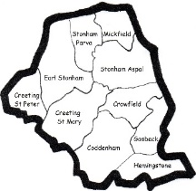
Wordsearch – Trinity 18
Based on the Readings Genesis 2. 18-24, Hebrews 1. 1-4; 2. 5-12, Mark 10. 2-16

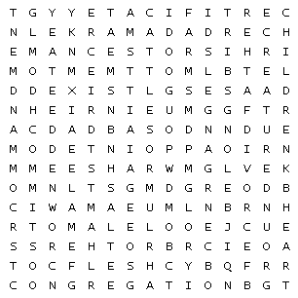

ADULTERY |  | ALONE |  | ANCESTORS
ANGELS |  | ANIMAL |  | APPOINTED
ARMS |  | BEINGS |  | BELONGS
BIRD |  | BLESSED |  | BONE
BROTHERS |  | BROUGHT |  | CATTLE
CERTIFICATE |  | CHILDREN |  | COMMAND
COMMANDMENT |  | COMMITS |  | CONGREGATION
CREATED |  | CREATURE |  | CROWNED
DEATH |  | DIVORCE |  | EXIST
FATHER |  | FEMALE |  | FIELD
FLESH |  | GENESIS |  | GLORY
GOD |  | GOOD |  | GROUND
HEART |  | HEIR |  | LORD
MALE |  | MAN |  | MARK
NAME |  | RIBS |  | SON

