COMMUNITY
LITTER PICK
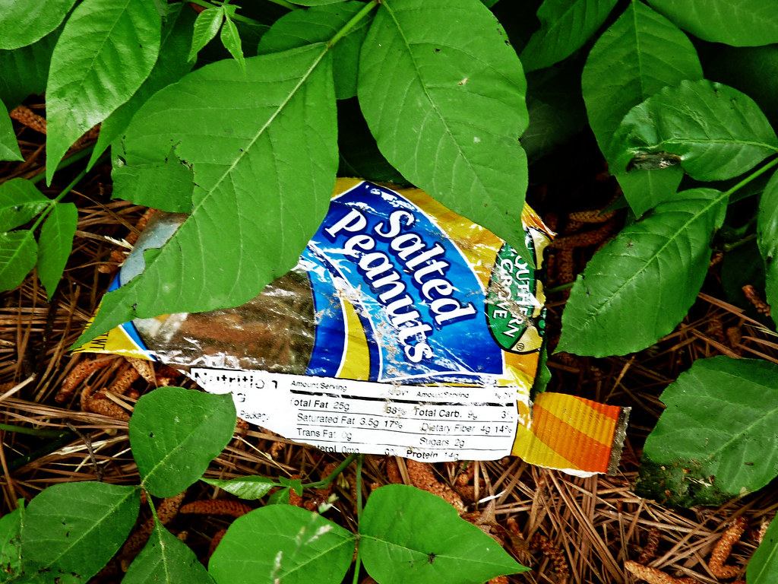
This Photo by Unknown Author is licensed under CC BY
Saturday 18th March
Starting from The Coddenham Centre
10.00 to 12.00
Please bring protective gloves.
Hi vis vests, Litter grabbers and bags will be supplied.
Refreshments provided by The Coddenham Centre
Coddenham Parish Council and The Coddenham Centre working together with the Community.

