Working Together colour logo.wmf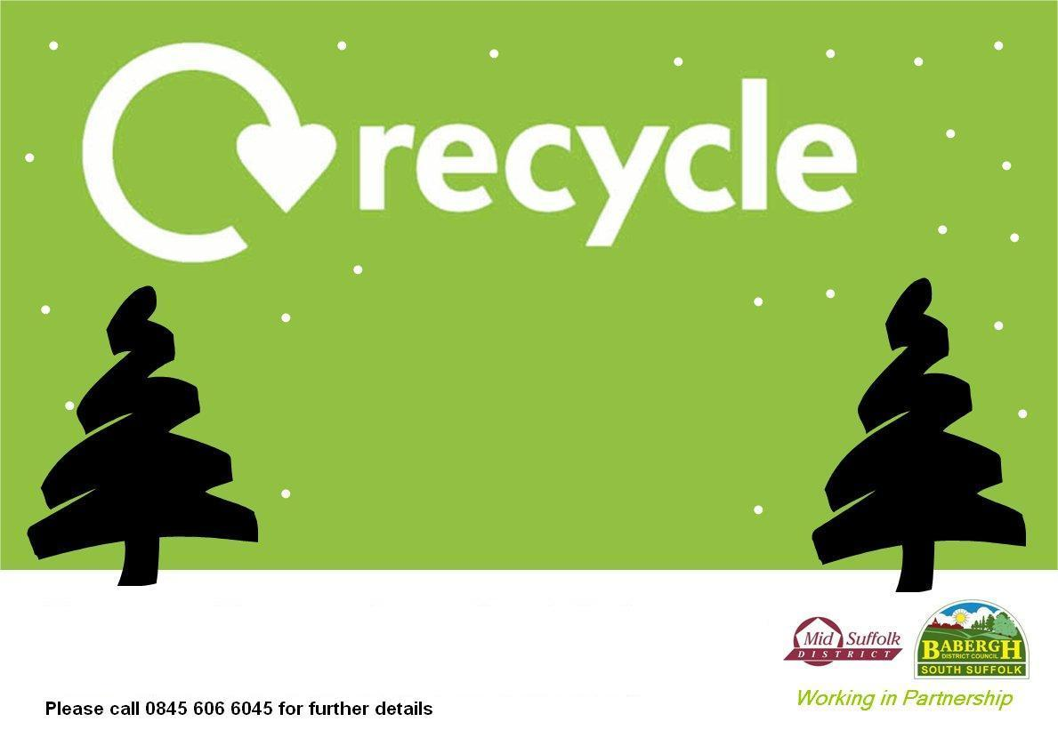

**‘Real’ trees can be left at this site from 7am on Friday 5th January, until 6 am on Thursday 11th January.**

**Trees must be less than 7’ tall & must have all decorations, stands & pots removed.**

**Please call 0300 1234 000(Option 4) for further details**

**Your Christmas Tree**

at

**The Coddenham Park Centre**