CODDENHAM VILLAGE HISTORY CLUB

THE REAL BASIL BROWN

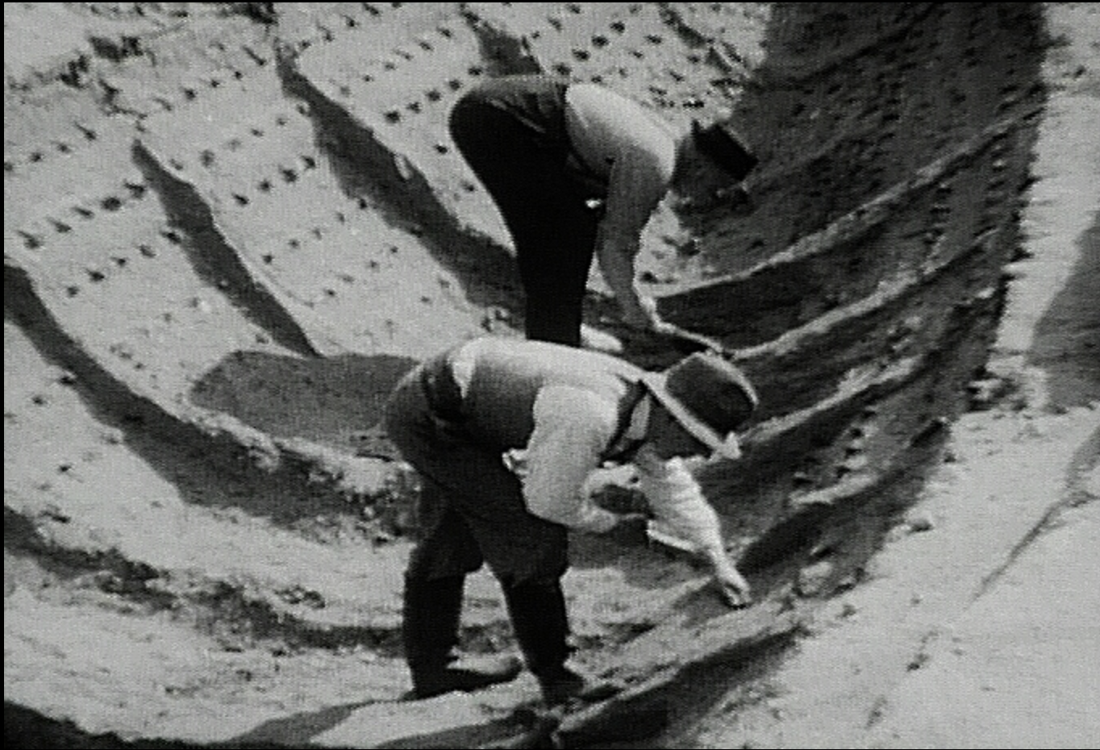

A talk by

SARAH DOIG

TUESDAY APRIL 16th at 7.30 pm

Haysel House – members free: non-members £3

