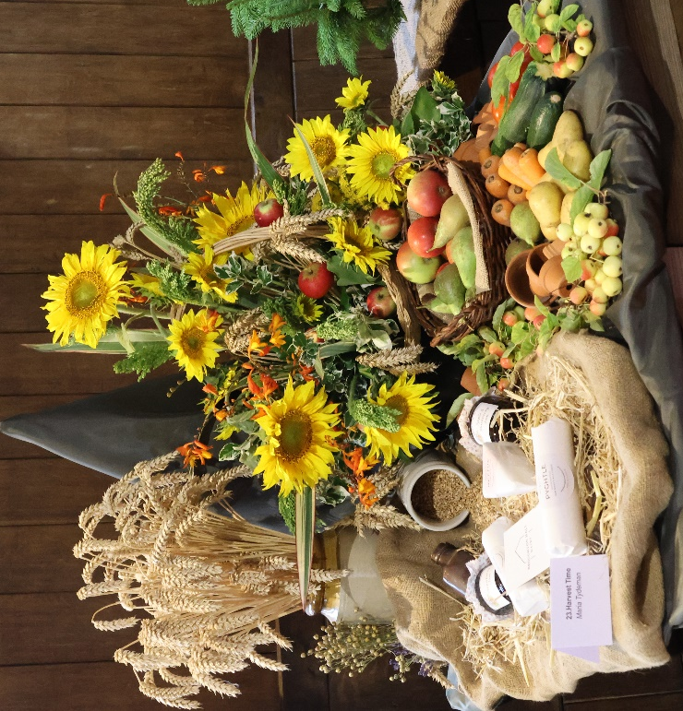
Crowfield Flower Festival
All Saints’ Church
August Bank Holiday Weekend
(Sat. 29th, Sun. 30th, Mon. 31st August 2026)

10.30am to 5.00pm daily

Fabulous flower displays on the fun theme of “DESERT ISLAND DISCS”
Home-baked hot and cold refreshments served all day, including bacon rolls & lunch

*Book and Jigsaw Stall *Picture trail for children *Produce Stall *Tombola & Raffle * Plant Stall

*Special celebratory service at the church at 10.00am on Sunday morning – all welcome

