CODDENHAM VILLAGE HISTORY CLUB

THE SieGE OF HAUGHLEY CASTLE & THE BATTLE OF FORNHAM in 1173

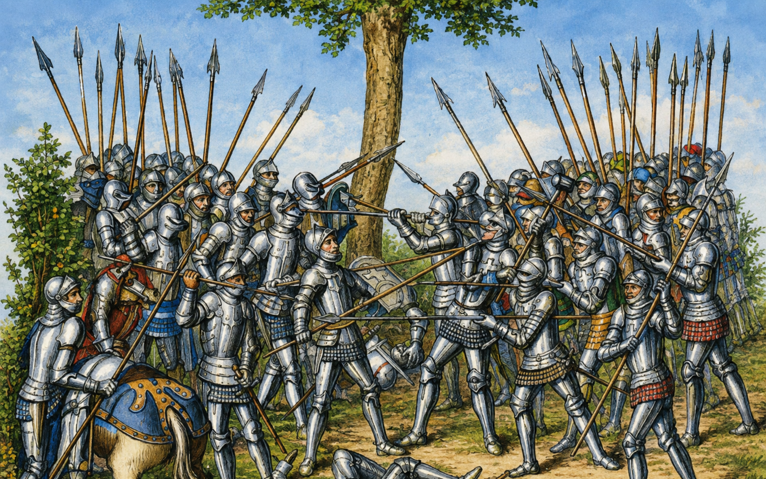

A talk by

Dr MIKE WALKER

TUESDAY SEPTEMBER 15th, 7.30 pm

Haysel House – members free : non-members £5

